**WELCME TO DANCE CLASS!**

**Physical Education**

Physical Education is said to be an education physically. The main goal of this is to expand student's understanding on certain action and welfare, and physical capability to make use of this to present in a wide range of activities together with the progress of an active and daily good habits. It also builds up the confidence of students and basic skills, specifically in terms of communication, collaboration, creativity, critical thinking and aesthetic appreciation. In accordance of supporting positive values and attitude in PE, arranging a well foundation for students' long term of learning.

Physical education contributes cognitive content and commandment created to build motor skills, knowledge and behavior for physical fitness and physical activity. Helping schools to form physical education every day that can give students the ability and confidence to be physically fit for a long time.

Physical Education is a certain subject that helps to educate students in school in which the main goal of this is to produce and enjoy every day physical activities with relief. Skills can be built also by kids that is needed to cooperate in a long range of activities like swimming, soccer, basketball, or physical education class that arrange kids to be physically and mentally active and ready to adulthood. Successful program about physical education should have lesson, trained PE instructors, adequate instructional periods and evaluation of students.

**Motor Learning**

Motor learning is sad to be similar to the development of motor skills and capability. It is also a structure that is part of programs related to physical education. There’s a three developmental stages of motor learning that needed to be taught in school. They also provide examples that can be improve to provide the needs of students.

Happens for a long span of time performing during which motor acuity, it’s the capability to perform actions appropriately, effectively and in short span of time.

Deals with the study of the development of skilled movements along with repetitions or other learning-associated components. He also stated that Motor learning experts at colleges and universities play an important role in undergraduate and postgraduate individuals.

**Dance**

Dance enhances heart health, increases endurance and coordination, improves mental function, and relieves stress, all while putting little strain on the body. Dance stimulates the brain on multiple levels: you must remember the steps, know how to transition from one movement to the next, stay in sync with the music and other people, and keep your balance while doing all of this.

All form of dance has its own language, as well as characteristics that are unique to it. The separation of different bodily parts, the grounded-ness of body's weight, and a rhythmic physicality are all stressed in Jazz and Hip Hop. Hip Hop's focus on society is indeed a key foundation; in group settings, there's also a call and response element that necessitates intuition and innovative thinking. The body's connection to space, as well as to self and other, is emphasized in the many distinct approaches used in modern dance. Learning a range of dance genres allows you to be more versatile in how you can interpret movement and choreography with your body.

Folk dance is a type of dance made by a group of individuals to represent a country's or region's culture and traditions. Folk dancing, as opposed to upper-class dance, depicts the dance styles of the ordinary people. Folk dances can develop naturally among groups of individuals or they might be derived from prior styles. Free-form or rigorously structured styles are also acceptable. Folk dance routines are passed from generation to generation and refuse to change once they've been created. Folk dancing is often linked with social events, but some dances are also competitively performed, and in some areas, folk dancing is also used in cultural awareness.

Several studies believe that dance integrates a variety of activities in uncommon ways, resulting in unique outcomes. After all, dancers must concentrate on stability, movement, grace, form, coordination, agility, synchronization, flexibility, rhythms, timing, and memory while keeping time with the music. These complicated and enjoyable activities seem to work together to build and maintain high overall health far into our golden years.

**MOTOR LEARNING IN DANCE**

**Motor Learning** is a significant part of every individual's life. It is present in every level of our experiences. Motor Learning means that dancers should have knowledge in skilled task both basic and complex. These skills are not accomplishing through motor development such as walking, skipping and grasping objects. This may also include balances that are not part of our everyday movement. The goal of the dance teachers is to teach this skill to the dancers so they can execute it in a smooth, expressive, accurate and will be retained on their memory. The objective for this is to achieve dexterity level that enhances movement quality.

Various **theories** have merged with regards to the history of motor learning and it was classified into two general classifications. This were categorized and related to the **two major types of motor control** namely **centrally controlled** and **environmentally driven mechanisms**. Several theories are focused in stages of learning. Motor learning theories include descriptions of various forms of learning and whether learners are consciously aware of their procedures in the learning experience or learn through repetition without any awareness. Eventually, researchers focused on differences between administrative learning.

Schmidt contends that when a movement is made, these **four elements** are stored:

1. Conditions at the start of the movement (such as weight or position of the body)
2. Parameters that can be varied (such as force, tempo, and velocity)
3. Sensory consequences (such as how the movement felt and appeared)
4. Knowledge of results (the outcome)

The mentioned four elements are eventually engrossed in a schema in two sections, and the motor programs contain both. **Recall schema** is the first section that is used to represent the motion portion, in which it provides actual outcomes or desired responses. Every time movements were made, the recall schema creates a relationship between specific parameters and provides actual outcomes.

The second section is the **recognition schema**. It is used to represent the sensory portion and assess the result and update the motor program to fix the error. The second section contains sensory consequences and previous results of the movements. In conclusion, the more variations had been present in practice, the stronger the schema is once the movement had been made. This theory shows that learning is reliant on continuously updating the recognition schema by putting the outcomes of new attempts that can be understood through knowledge of outcomes. Furthermore, Schmidt’s theory also proposes that a movement never before made can be done successfully if it is based on the previously implemented rule. In the example of dancers learning turns, after they had executed enough variety of turns, they can accomplish new arm or leg positions in a turn at a high measurement of skill. Although the idea of the variability of practice look rational, it has not been actually supported in research. In some cases, research on children looks more accommodating on the use of variable practice for motor learning the research on adults. The dissimilarity may take place because adults are normally experiences a major amount of movements than children that are totally not familiar with the new movements and not yet performed the said schemas.

Additionally, **recall and recognition schemas**, the *generalized motor program (GMP)* is the *central idea* of **Schmidt’s theory**. **Generalized Motor Program (GMP)** is a program that authorize the motor system to perform a major class of analogous movements or actions. This is stored in our memory and needed random parameters to be added in the next execution. It allows the motor system to accept variety of motor programs. **Parameters** contains the speed, force and body parts that relies from one execution of GMP to another. **Invariant features** are called the signature of GMP. These are the features that do not switch from one action to another within the same class. The GMP theory focused on the ballistic and fast movements, in which absence of time limits the ability to use feedback.

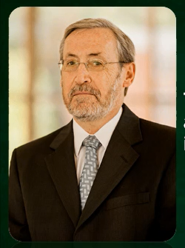**ECOLOGICAL THEORY**

In the **late 1970s**, new theories regarding motor learning started to appear. These theories were product of all ideas from the ecological perspective or ecological theory. This approach highlighted the **relationship between the environment, individual and the task**. Movements need knowledge from the environment (perceptual information) that is focused to the desired motor movement.

A well-known ecological motor theorist, **Karl Newell** draws mostly of his theories from the scheme of both dynamics systems theory and ecological perspective. **Dynamic systems theory** assesses the body as the mechanical system, and see behavior as emerging from the relationship of the nervous system and the environment. This approach emerges with the interaction with their partners. In the other hand, the starters seem to have conflict more with the steps and need to focus and concentrate mostly on executing the dance form.

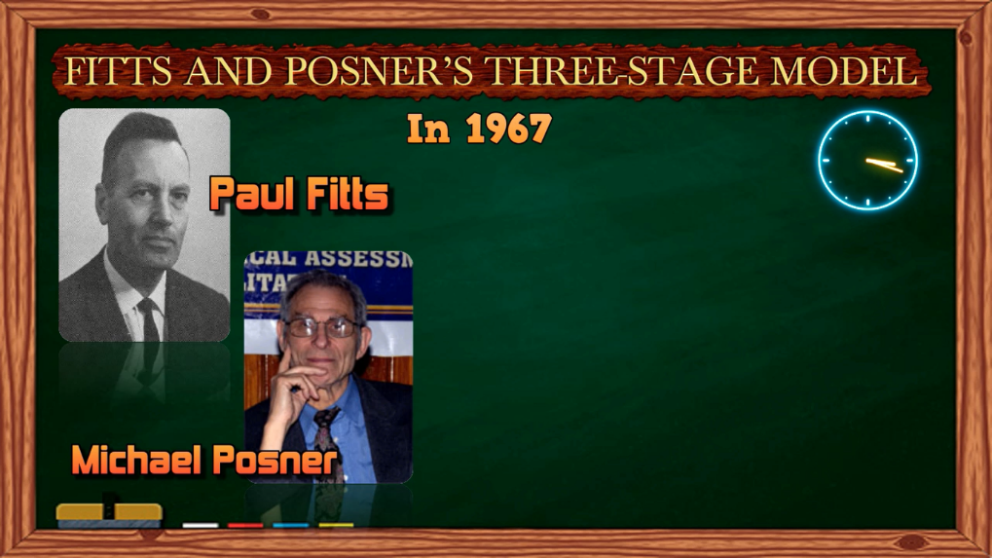**FITTS AND POSNER’S THREE-STAGE MODEL**

In 1967, psychologists and researchers **Paul Fitts** and **Michael Posner** established a model for learning stages that is still used today. The **cognitive stage, the associative stage, and the autonomous stage,** according to their idea, are the stages in which a skill is learned. The simplicity and practicality of this idea are among the numerous reasons why coaches and dance teachers find it appealing to use in training.

**DEFINING THE STAGE**

* 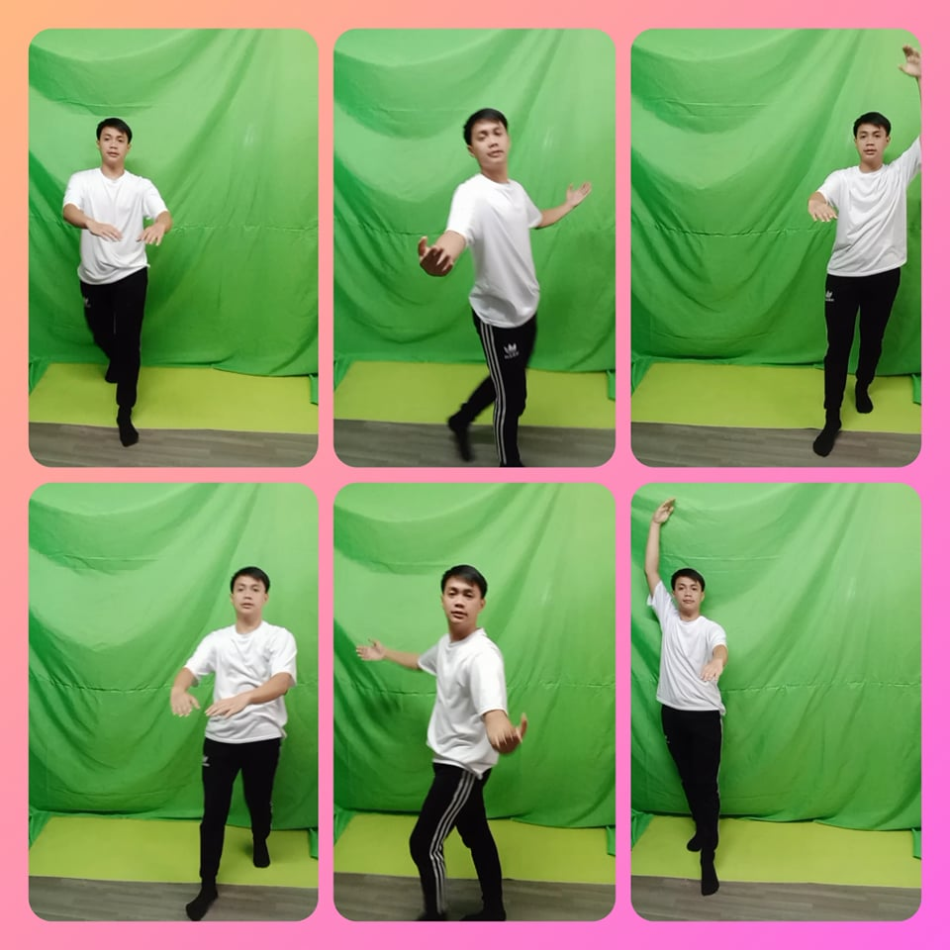**The Cognitive Stage**

The learner learns to know the nature of the task, develops new strategies for accomplishing the task, and determines how to best evaluate which strategy to employ during the first step (**the cognitive stage**). This stage demands a lot of focus, and the learner tries out a variety of tactics. In addition, the student pays attention to detailed feedback and seeks out teacher support. Performance is inconsistent, with numerous faults, and improvements are significant. Learners at this stage are generally aware when something is wrong, but they are unsure how to fix it. They begin to develop the ability to evaluate their own abilities and the selective attention required for the many components of the work.

* 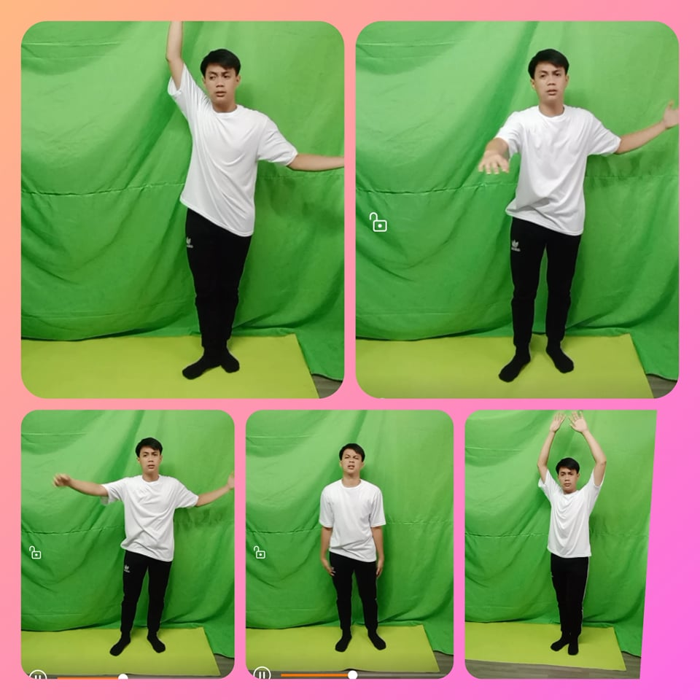**The Associative Stage**

The skills are developed during the second stage (**the associative stage**), which means that the dimensional and material components of the skill become more organized. From one trial to the next, the movement is less variable, and so improvement is slower. When a pupil enters this stage, no set quantity of practice or level of growth is required. The verbal and cognitive aspects are not so much as important in this second stage; the reason is that students need to learn to identify the specific environmental conditions with what is needed. Errors are not that frequent and less extreme, the student is starting to learn how to identify the exact errors without the help of the teachers. A load of feedback starts to change from visual to proprioceptive. The main goal of this stage is to enhance the motor pattern organization.

* 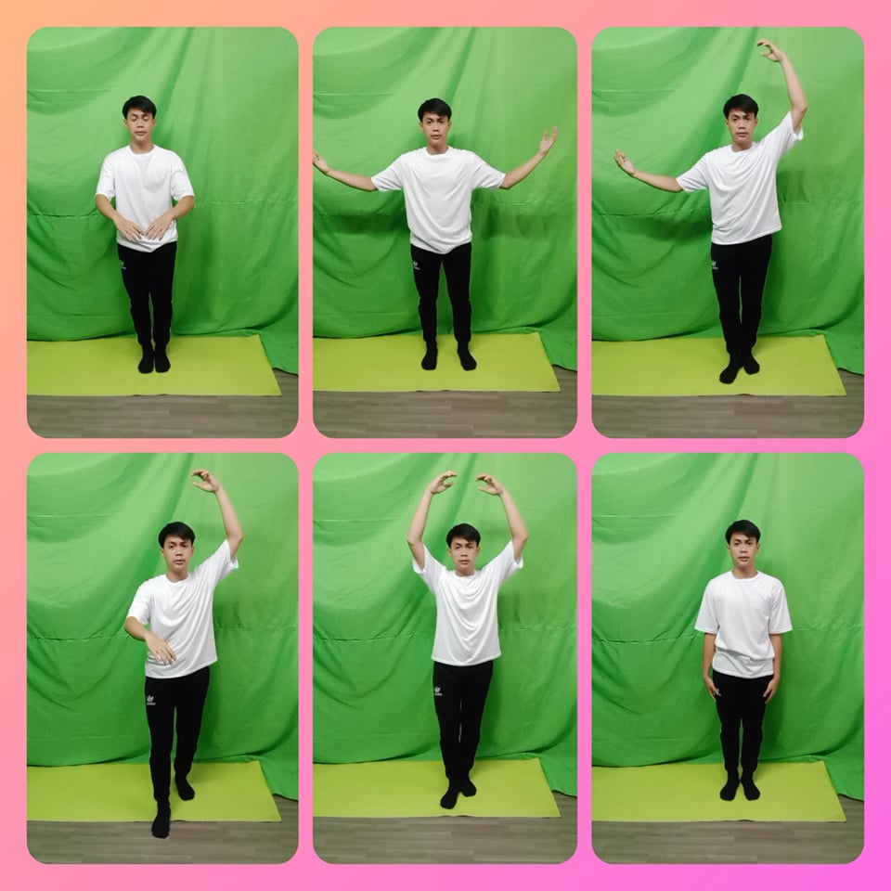**The Autonomous Stage**

The third and final stage doesn’t require attention at all, it only happens after enough practice and experience with the task. An individual can do the activity or task and do other tasks simultaneously as action is fairy automatic or habitual. In this stage, putting too much recognition on components of the skill can reduce performance. In this stage, variability is less. In other terms, recurrent executions can produce effective performance. Practicing tasks in a different environment and condition is critical. In the autonomous stage. Students can identify and fix their own errors. Fitts and Posner were confident that it’s not viable for all to achieve **the autonomous stage** on a given activity. Elements that assess whether or not this stage can be reach including the quality of instruction, the quality and amount of practice. The main goal of this stage is to build a high level of skill and performing with consistency on the said level.

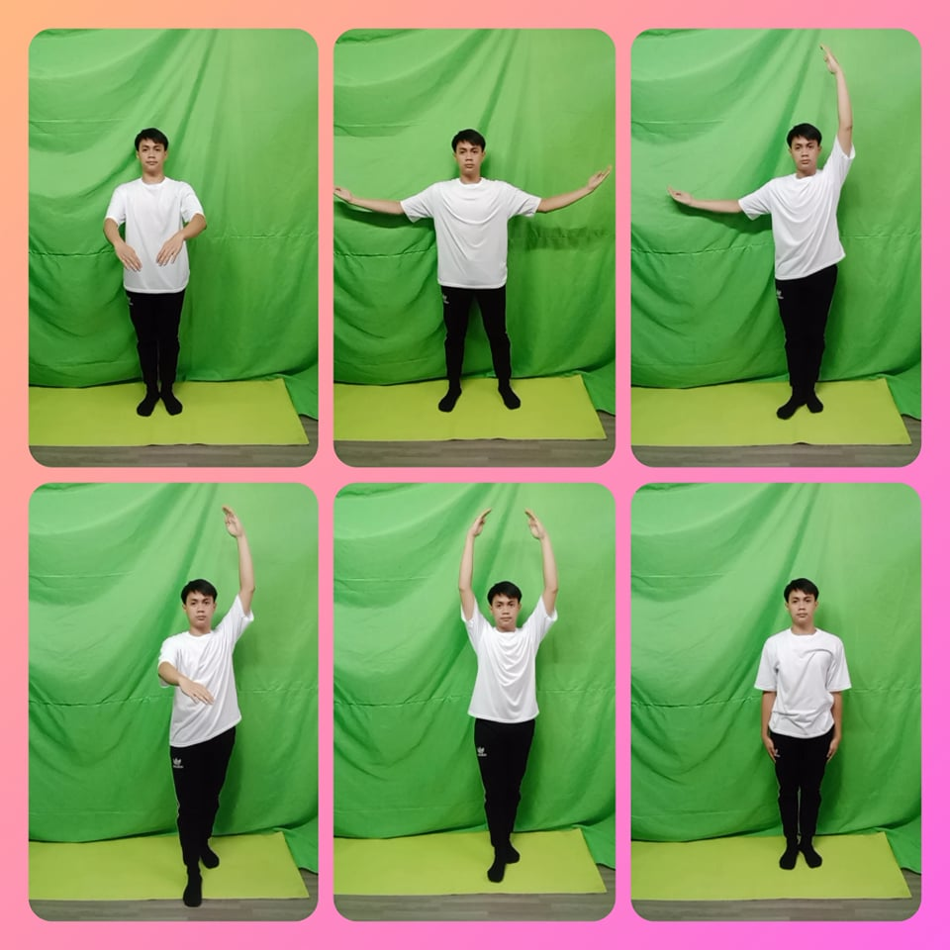**GENTILE’S TWO-STAGE MODEL**

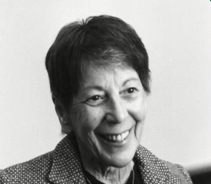**Antoinette Gentile**, a psychology professor, implement a two-stage model of motor learning that focuses on the goal of the learners. The two stage are namely the Initial stage and the later stages.

**Closed skills** are abilities that are done absolutely the same way each time. With repetitive process the skill gets to be more steady and productive, which is known as **fixation**. Dancers put numerous hours over a few months practicing the same expertise within the indistinguishable design in arrange to improve reliable execution. **Open skills** are skills that requires to be executed in many variety of gestures, timing, and spacing such as leaps. This involves conditions that are changing mostly, like a use of space and broad range of tempos. **Diversification** is the ability to enhance the skill to various conditions and criteria and to adjust quickly.

**CHANGES ACROSS LEARNING STAGES**

**Both Gentile’s and Fitts and Posner’s model of motor learning** has a similarity when it comes to learners showing certain characteristics as they went through different stages. These characteristics include following changes:

* ***Improvement Rate*.** When learners develop to be more advance, the rate of improvement lessen. Major improvements happen in early stages. This interaction is called *power law or practice*. Even though improvement spread quickly it is breakable and can be easily lost. However, learning is slowest in the late stages, but it is powerful and likely to support over time.
* ***Coordination.*** Performers must solve the *degrees of freedom problem* in the early stages of learning. Degrees of freedom problem is a prevention of issue for the motor system to identify how to restrict the degree level of freedom to attain a task.
* ***Adjustments to familiar movement patterns or habits.*** Trying a skill that represents a skill that is well-known they show bias actions then they know how to adopt new strategies.
* ***Muscle selection during a skill.***Extra muscles are use than are needed on the primary level of learning in which timing of activation is mostly not correct. Thereafter, count of muscles that had been used is decreasing.
* ***Use of energy (movement economy).***On primary level, Dancers attain immoderate level of energy and in the secondary level of learning, economy of actions is the goal.
* ***Attention to meaningful visual cues.***From early level of learning up until learning expanded. Dancers had been developing to be more effective visually on what is require in order to finish task.
* ***Demands on conscious attention.*** Starter requires to consider all aspect of the new skill but the professional learners can focus on the task until it became natural.
* ***Ability to detect and correct errors.*** In the primary level of learning, even though starters were aware when they had made an error, they didn’t know how to correct it but in the next stages they need to know and correct this.
* ***Activity in the brain.*** Part of the brains were considered different in terms of being active in the primary up to last stages of learning.

Nevertheless, the theories carry the idea that all learners should overcome various levels to proceed from starter to skilled mover.

**FORMS OF MOTOR LEARNING**

Apart from theories and level of motor learning, various types of learning influence dancers. Overall, types of motor learning can be categorized into declarative and nondeclarative learning.

1. **Nondeclarative Learning**

Nondeclarative learning also called implicit learning means learning with less effort and achieved with just repeated exposure. Kids always learn dance skills such as jumping and turning by copying their teacher’s movements without knowing that they already absorbed them. Nondeclarative learning can be categorized into associative, nonassociative and procedural learning.

* **Nonassociative Learning**

This usually happen when one stimulus given repeatedly and nervous system adapt to it. The two main types of nonassociative learning are habituation and sensitization. **Habituation** happens when repeated exposure to a nonpainful stimulus start to decrease receptiveness. **Sensitization** happens when repetitive exposure to an identified threatening stimulus start to increase receptiveness.

* **Associative Leaning**

This usually happen when two ideas or stimulus are together. Example of this is when movement and music become connected as one. Occasionally, associative learning can produce cause and effect scenario. Two known types of associative learning are classical and operant conditioning.

* **Classical Conditioning** helps an individual to know the bond between two stimuli in the environment.
* **Operant Conditioning** is voluntary and a trial and error learning. Somehow an individual knows to give a certain response among others with a corresponding consequence. This type of learning follows the **law of effect.** This law states that recognized behaviors are selected for the sake of other behaviors.
* **Procedural Learning** is known as obtaining a movement skill by repeating it over and over again without no conscious attention. Progress of learning is slow through continuous repetition and expressed through polish performance.

1. **Declarative Learning**

Also known as explicit learning which the outcome in knowledge that can be recalled consciously. It attains attention and reflection. Suppose to be this is not actually a form of motor learning but might help in learning motor skills such as learning the name of steps or skills in dance class.

**McCarthy and Kolb: Combining Two Theories**

**Bernice McCarthy**, an educator, and author explains the four learning styles in her educational system, which is named as 4MAT:

* **Dynamic:** experimentation and trial and error, risk takers, intuitive
* **Innovative:** social interactions and discussion, cooperative
* **Common Sense:** hands-on and practical, more cautious
* 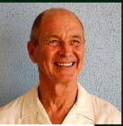**Analytic:** logical, seek facts in systematic ways

Another educational theorist, **David Kolb** that concentrates working on experiential learning. He explains the cycle of learning which includes the following:

* Concrete experience
* Reflective observation
* Abstract conceptualizing based on observing and reflecting
* Testing the new ideas through experimentation

**Debra Rose and Roberta Christina** both authors had emerged these two theories into a single model for learning purposes. These emerged models set learners by both personal style and activity preferences. This explains that a certain dancer can learn better through experimentation (dynamic) with precise movement. Other dancers maybe logical, analytic descriptions (analytic) and respond to what is observed in the demonstration.

A well-known thread through all types of theories and systems of learning is that each learner is unique and has varying strategies and preferences in the learning journey. If instructors are able to use one teaching method, such as demonstration they will only achieve a part of the class. Teachers can decorate lessons to incorporate different learning forms and taught each student.

**Training Dancers to Execute a Dance Task**

**Kuradang Dance Step**

1. **Adam’s closed loop theory**

Performers can develop a deeper knowledge of the theories, stages and forms of learning by investigating the process of learning. If you want to know this skill, you can check on Adam’s closed loop theory. Definitely mostly repeated attempts of this task in a non-locomotor situation would be good starting point. For starters, it’s acceptable to modify the task, Perhaps it’s more relevant to try the task without help and continuously repeat the task until it’s finish according to Adam’s theory.

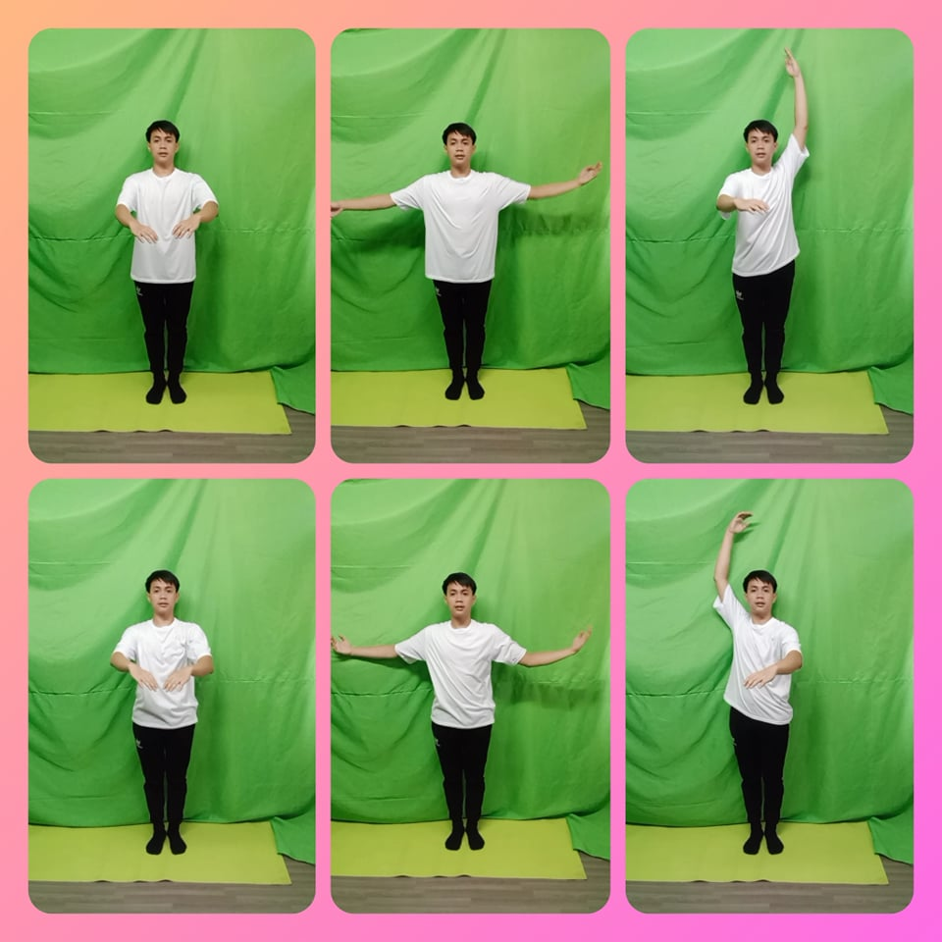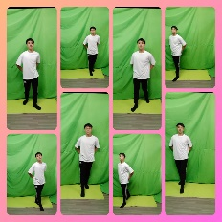

1. **Schmidt’s theory**

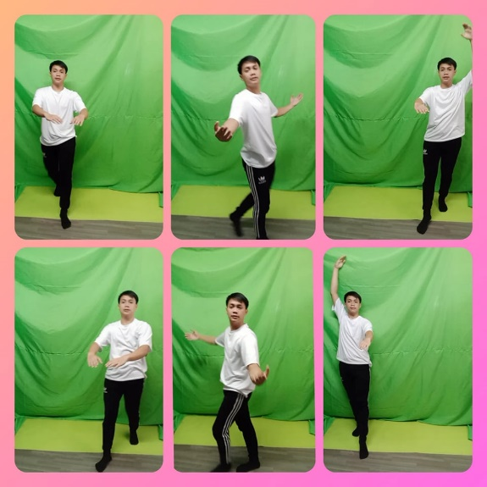It is said that it’s more relevant to provide multiple versions of a one-legged balance to create the schema of the skill. Examples is when the gesture leg is in parallel as we as externally rotated and the arms position are differing in multiple ways. When the performer learns the schema, the right posture will be developing in different types of position and not just the first one that is learned. Movement and wide range of positions requests that instructors and choreographers make on dancers, it is helpful for dancers to know the schema for basic types of balances and movements.

1. **Newell’s ecological theory**

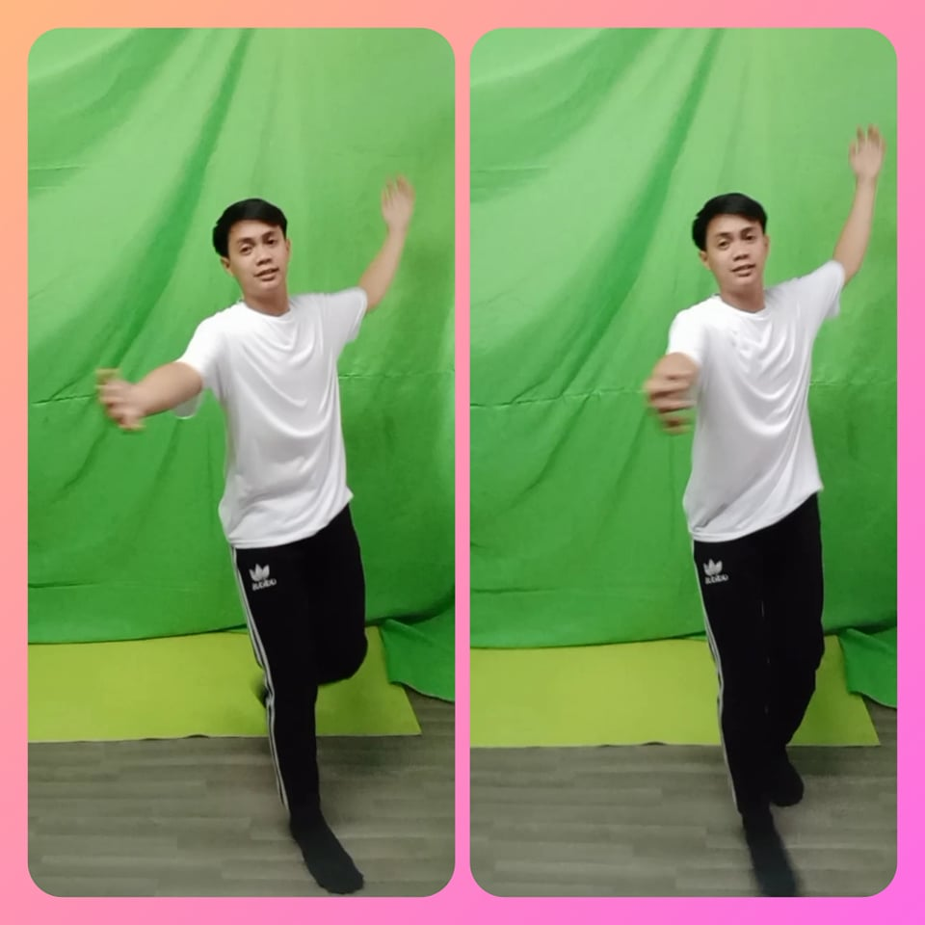Highlighted active problem solving, student should be persuaded to seek and discover various solutions to problems with the task. Let student know that they should let and try different solutions than instructing them what to do is an effective learning tool. Most of the time students want a direct answer, asking explainable questions is a good technique for them because it helps in developing internal error detection and correction mechanisms.

1. **Fitts and Posner’s stages of learning model**

An effective guide for students and instructors when they want to learn in advance. If student is under cognitive stage, this particular student is discovering various strategies with high rate of success. At some point, student can gain knowledge from the teacher’s feedback and guidance. When student is using the technique during associative stage, there’s many challenges that can be seen in the task. After the balance mechanisms became automatic, the student can now reach the balance while the attention is focused on other criteria. If the balance worsens when other balance had been added the result will be student may not have achieved the autonomous level and require continue practice.

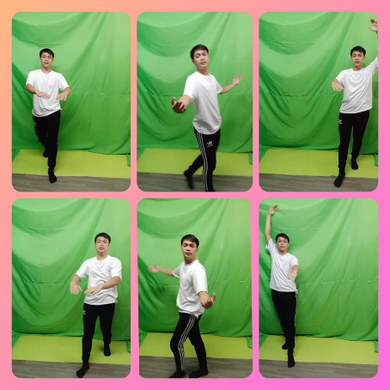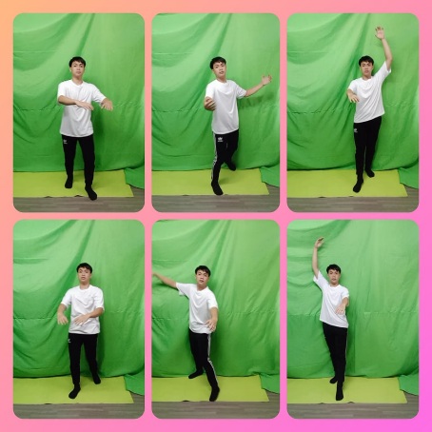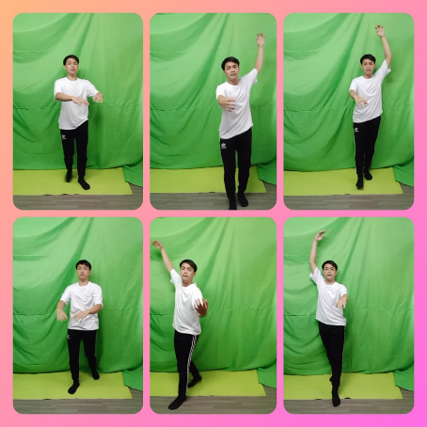

1. **Gentile’s two-stage model**

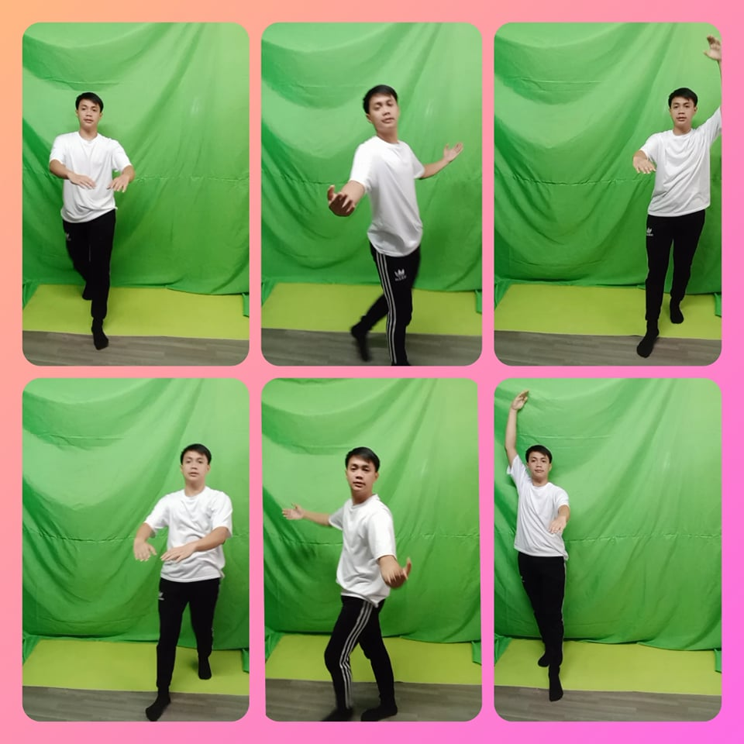it is essential to begin with the goals for the early stage and be attentive on teaching the unity of movement. Performers need to know the basic pattern of shaping the gesture leg alternately using arms positions. Although the different parts can be practice by one’s self at the beginning, the participation of all the components must be relative early in the process. Musicality is necessary in dance. Operant conditioning can be use by complimenting the dancers when they do a good balance is one way to use this form of learning. On the other hand, it is efficient to look an intrinsic positive association like making performers aware of their goals that can be reached if the balance is perfected.

Above all of this processes, dancers and teachers should address the broad variations of learning techniques using demonstration, analytic description, exploration and social interaction to know several techniques.

**WATCH OR DOWNLOAD VIDEOS/PICTURES ON:**

**YOUTUBE:**

https://www.youtube.com/channel/UCnN-ar26sexOpWpQosoGvWw

**GOOGLE DRIVE:**

https://drive.google.com/drive/folders/1AGOw6xNfxDA45DO8HUdW5JbtZ18nwLGY?usp=sharing

**REFERENCES**

Advancement Courses (A willy Brand)., (2020, February 18). Using Dance in PE Class.

<https://blog.advancementcourses.com/classroom-activities/dance-pe-class/>

Bedinghaus, T., (2019, February 24). Folkdance: Definitions and Styles.

[Dotdash Meredith](https://www.dotdashmeredith.com/)

<https://www.liveabout.com/folk-dance-overview-1006565>

Centers for Disease Control and Prevention., (2020, April 21). Physical Education.

<https://www.cdc.gov/healthyschools/physicalactivity/physical-education.htm>

Education Bureau., (2021, September 19). Curriculum Development.

<https://www.edb.gov.hk/en/curriculum-development/kla/physical-education/index.html>

Hum, N., (2021, December 20). Long-Term Motor Learning in the “Wild” With High

Volume Video Game Data.

<https://www.frontiersin.org/articles/10.3389/fnhum.2021.777779/full#B61>

Modrzejewski**,** M., (2018, September 5). From the Faculty: The importance of different

dance techniques. HUBBARD STREET DANCE CHICAGO.

<https://www.hubbardstreetdance.com/about-us/blog/from-the-faculty-the-importance-of-different-dance-techniques/#:~:text=Learning%20a%20variety%20of%20dance,is%20dance%20or%20otherwise)%20enhances>.

Radiance dance studio., (2019, November 15). Life Benefits of learning to dance.

<https://www.danceradiantly.com/life-benefits-of-learning-to-dance/>

Spittle, M. (2021). Motor Learning and Skill Acquisition: Applications for Physical

Education and Sport (2nd ed.). Bloomsbury Academic.

<https://books.google.com.ph/books/about/Motor_Learning_and_Skill_Acquisition.html?id=PKVvXwAACAAJ&redir_esc=y>

Study.com., (2020, April 4). What is Physical Education? - Definition & Overview

<https://study.com/academy/lesson/what-is-physical-education-definition-overview.html>

Study.com., (2021, November 13). Teaching Motor Learning Concepts in Physical

Education. <https://study.com/academy/lesson/teaching-motor-learning-concepts-in-physical-education.html>